Visualization of parameters generated locally for Go trials. In visualization function n_rep=100,000

1. Parameters: [0.008, 0.22, 0.06, 1.76, 1.29]  
   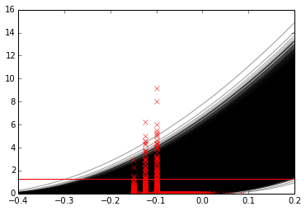
2. Parameters: [0.010, 0.22, 0.04, 1.23, 1.05]  
   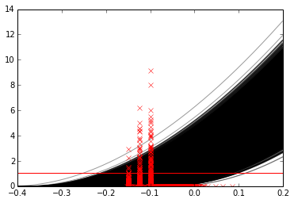
3. Parameters: [0.003, 0.19, 0.02, 2.04, 1.61]  
   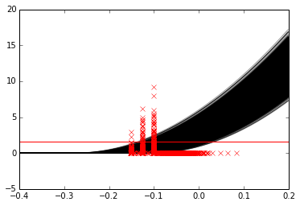

Third option makes sense experimentally/physiologically